

**MBARARA UNIVERSITY OF SCIENCE AND TECHNOLOGY**

**FACULTY OF COMPUTING AND INFORMATICS**

**BACHELOR OF COMPUTER SCIENCE**

**COURSE NAME: WEB APPLICATION DEVELOPMENT**

**CODE: CSC 2207**

**LECTURER: MR. YONASI SAFARI**

**INVENTORY MANAGEMENT SYSTEM (WEB-BASED APPLICATION)**

**CASE STUDY: PATTY’S STORE**

**BY**

**ADRIKO PATRICIA LAWURI 2022/BCS/O23/PS**

**PROJECT REPORT 23RD MAY,2024**

**Table of Contents**

**List of figures** 3

**List of tables** 3

**Introduction** 4

**Project Background** 4

**Problem statement** 4

**Main Objective** 4

**Motivation** 4

**Literature review** 5

**Methodology** 5

**Business Case** 6

**Functional Requirements** 6

**Non-Functional Requirements** 6

**Design** 6

**Use Case Diagram** 6

**System Architecture** 7

**Sequence Diagram** 7

**Code Structure** 7

**Testing** 7

**Implementation** 8

**Challenges faced during development** 10

**Future Improvements** 10

**Conclusion** 11

**References** 11

## **List of figures**

Figure 1.Agile Methodology 6

Figure 2 .Use case diagram 7

Figure 3.Three-tier architecture 7

Figure 4.Sequence Diagram 8

Figure 5.Login Page 8

Figure 6.Authentication 9

Figure 7.Staff Registration Page 9

Figure 8.username already exists & common password 9

Figure 9.Staff view 10

Figure 10.Logged in user Profile 10

Figure 11.Admin Dashboard 10

Figure 12.Product Page 11

## **List of tables**

Table 1.Literature Review 5

## **Introduction**

In this report, I provide a comprehensive overview of my web development project, in which I developed an Inventory Management system website using Django as the backend framework. This project allowed me to immerse myself in web development, from design, development to functional implementation, while integrating the power of Django.

### **Project Background**

Technology plays a significant role in various fields, including the business sector. Currently, manual systems are prevalent in stores, leading to errors and increased workload. The Inventory Management System is designed to enhance accuracy, speed, and efficiency.

### **Problem statement**

Patty’s Store currently relies on a paper-based system, making it challenging to manage inventories, track orders, and handle employee details.

### **Main Objective**

The main objective is to design and implement a computerized inventory management system to improve efficiency at the store.

## **Motivation**

Managing a retail shop efficiently is a challenging task that requires constant attention to detail, accurate record-keeping, and effective inventory control. My dad's shop (Patty’s Store), like many small businesses, has been facing difficulties with manual inventory management, leading to challenges such as stockouts, overstocking, and inefficient tracking of products. These issues not only affect the shop's operational efficiency but also impact customer satisfaction and profitability.

The Inventory Management System project is motivated by the desire to transform Patty’s Store into a more efficient, customer-focused, and growth-oriented business.

## **Literature review**

|  |  |  |  |  |
| --- | --- | --- | --- | --- |
| No | Literature | Strength | Gap | Solution |
| 1 | Jayanth, S., Poorvi, M.B. and Sunil, M.P., 2017. Inventory management system using IOT. In *Proceedings of the First International Conference on Computational Intelligence and Informatics: ICCII 2016* (pp. 201-210). Springer Singapore. | Uses IOT | Expensive in terms of purchasing equipment | Develop a web-based solution |
| 2 | Madamidola, O.A., Daramola, O.A. and Akintola, K.G., 2017. Web-based intelligent inventory management system. *International Journal of Trend in Scientific Research and Development*, *1*(4), pp.164-73. | Web-based Application | This system suites businesses operating on large scale as well as those with multiple warehouses | A web-based system suitable for retail shops operating on small scale |

Table 1.Literature Review

## **Methodology**

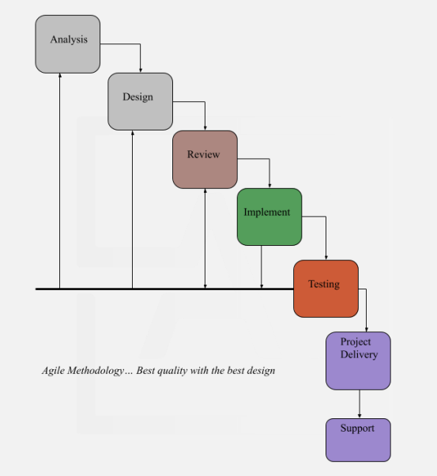

Figure 1.Agile Methodology

I followed the Agile Methodology for Project Management where we will divide the whole project into incremental, iterative work sequences that are commonly known as sprints.

## **Business Case**

### **Functional Requirements**

* Generate reports of all products available, employees, and customers.
* Monitor stock levels.
* Search and query for data in the database.
* Update profile data
* View Profile details

### **Non-Functional Requirements**

* Data integrity through validation rules.
* Efficient and ease of usability of the system.
* Security through controlled access to the system.
* Reliability
* Availability

## **Design**

### **Use Case Diagram**

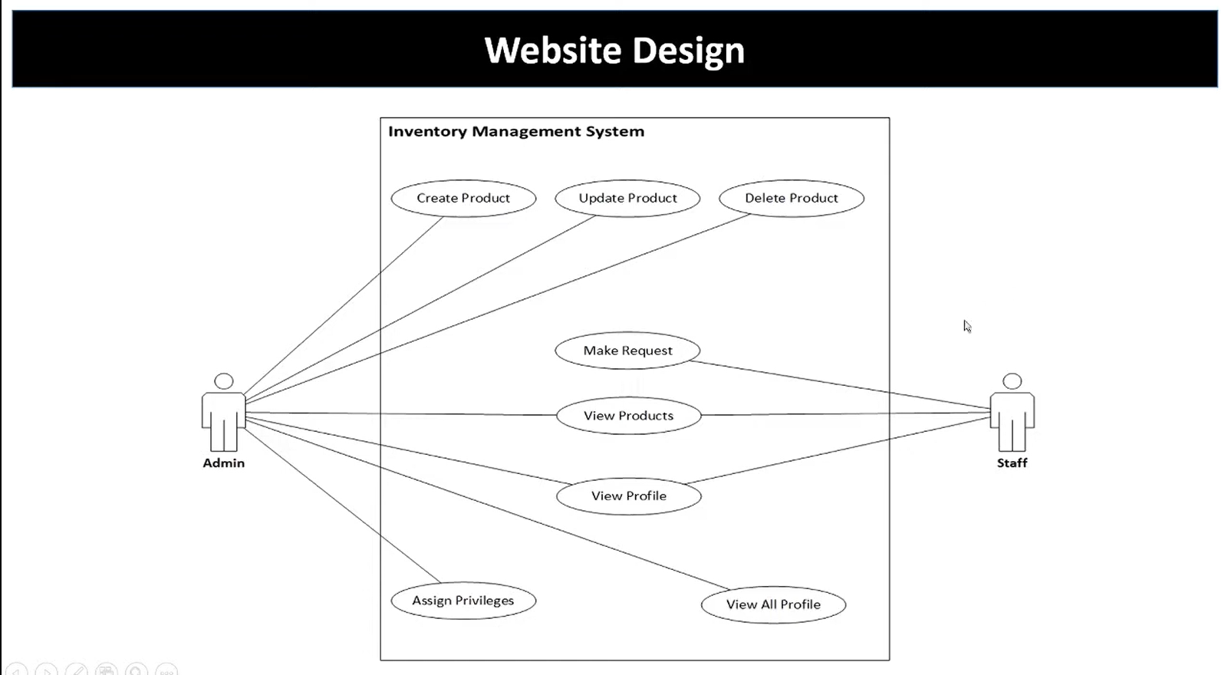

Figure 2 .Use case diagram

### **System Architecture**

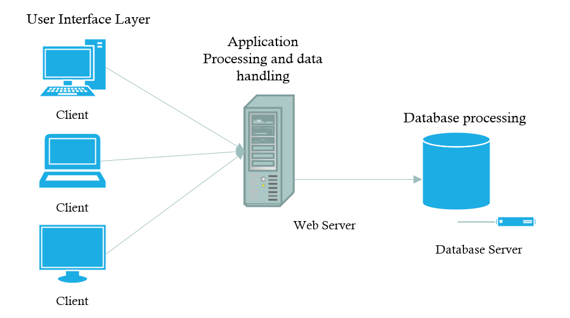

Figure 3.Three-tier architecture

### **Sequence Diagram**

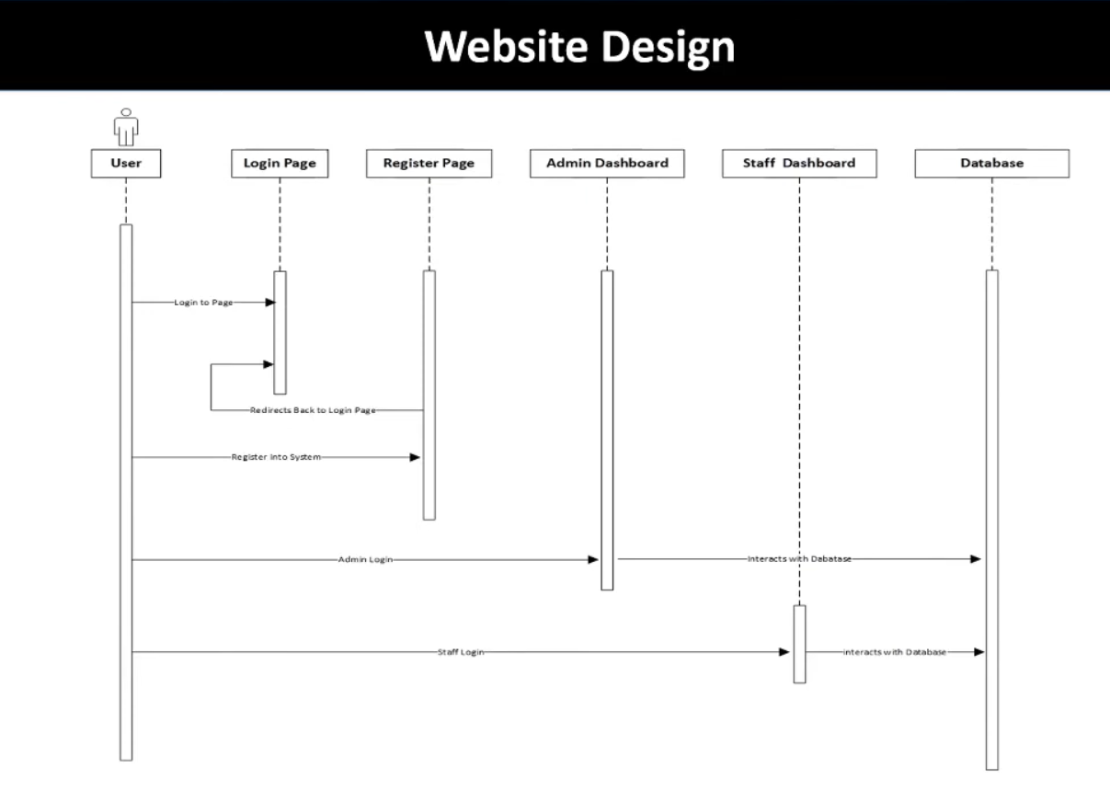

Figure 4.Sequence Diagram

## **Code Structure**

Django's project and app structure naturally organizes code. I maintained separation between HTML templates, CSS, and JavaScript files within each app.

## **Testing**

I extensively tested the websites on various devices and browsers to identify and address any layout issues, broken links, or JavaScript errors. Cross-browser compatibility was achieved through targeted testing and adjustments.

## **Implementation**

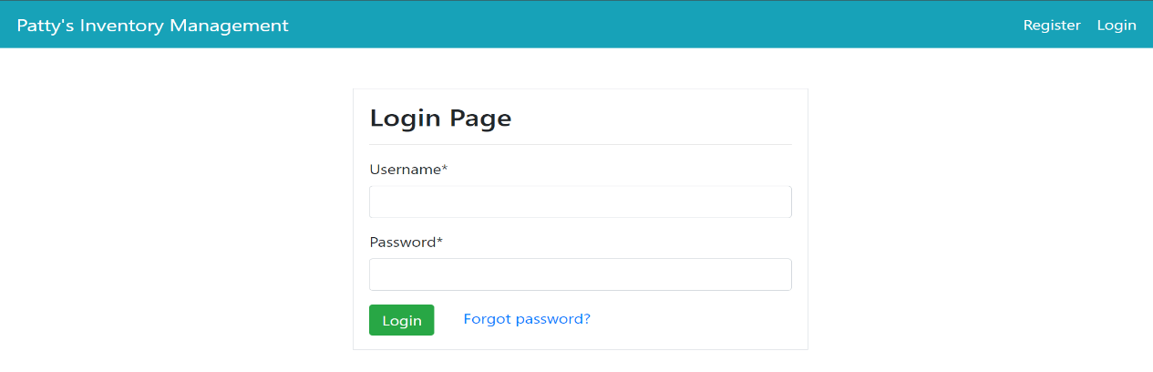

Figure 5.Login Page

The login page is the primary interface for accessing the system, granting permission to other pages based on correct email and password. It determines the level of access authorization for each user, determining the page displayed.

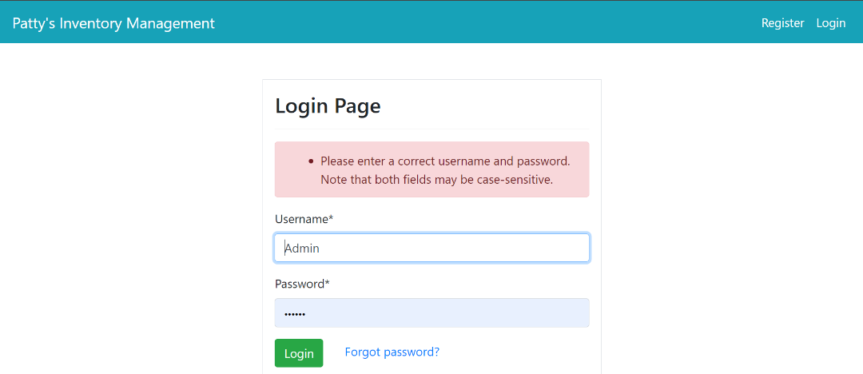

Figure 6.Authentication

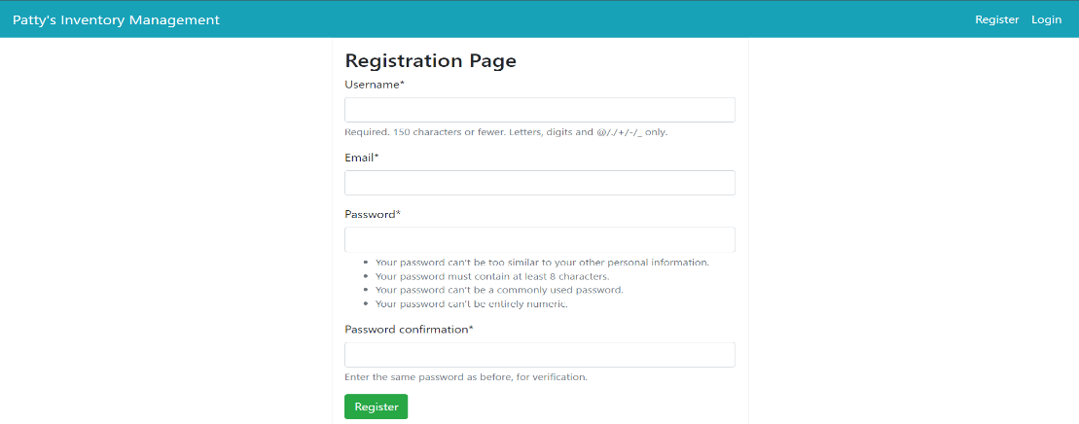

Figure 7.Staff Registration Page

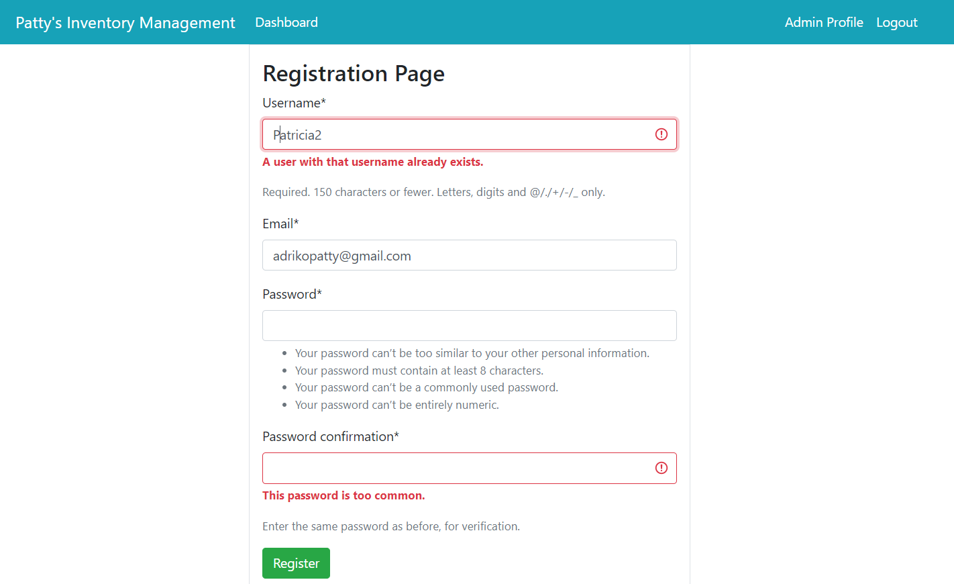

Figure 8.username already exists & common password

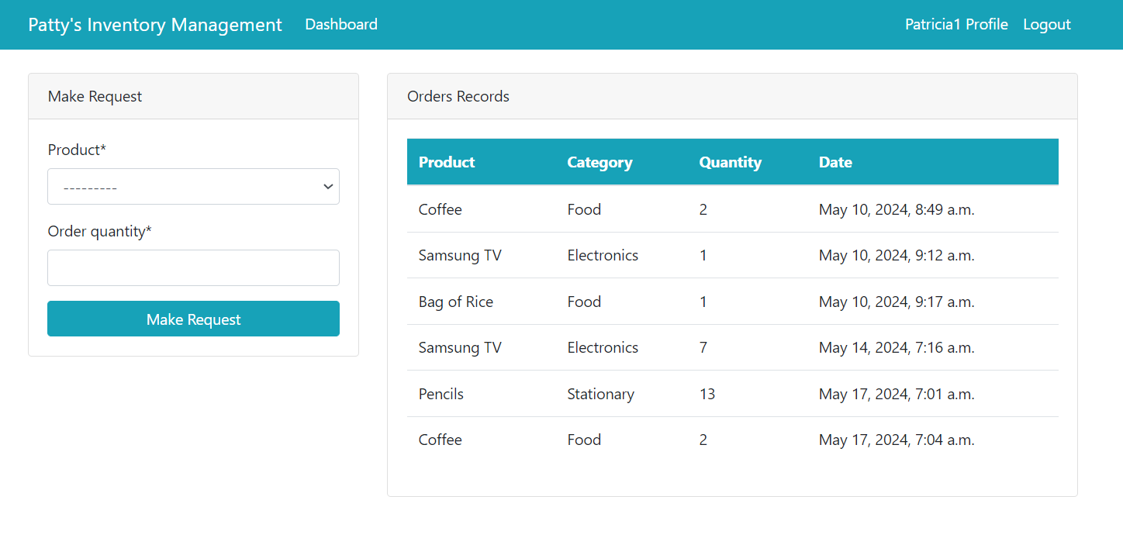

Figure 9.Staff view

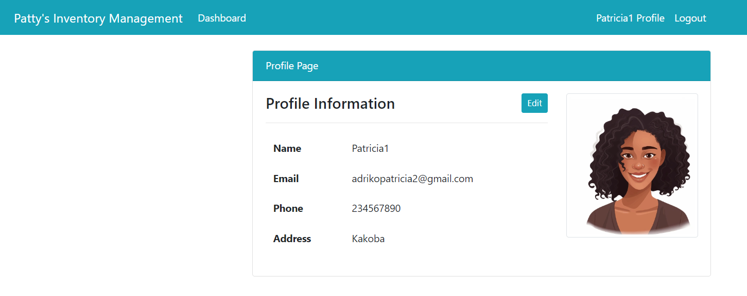

Figure 10.Logged in user Profile

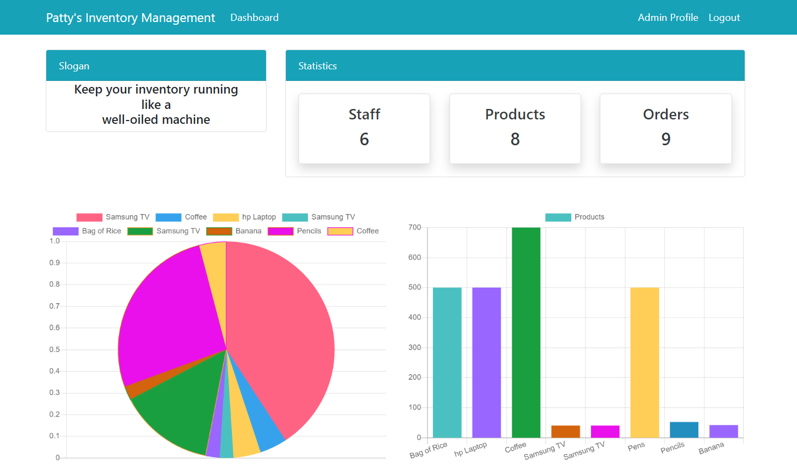

Figure 11.Admin Dashboard

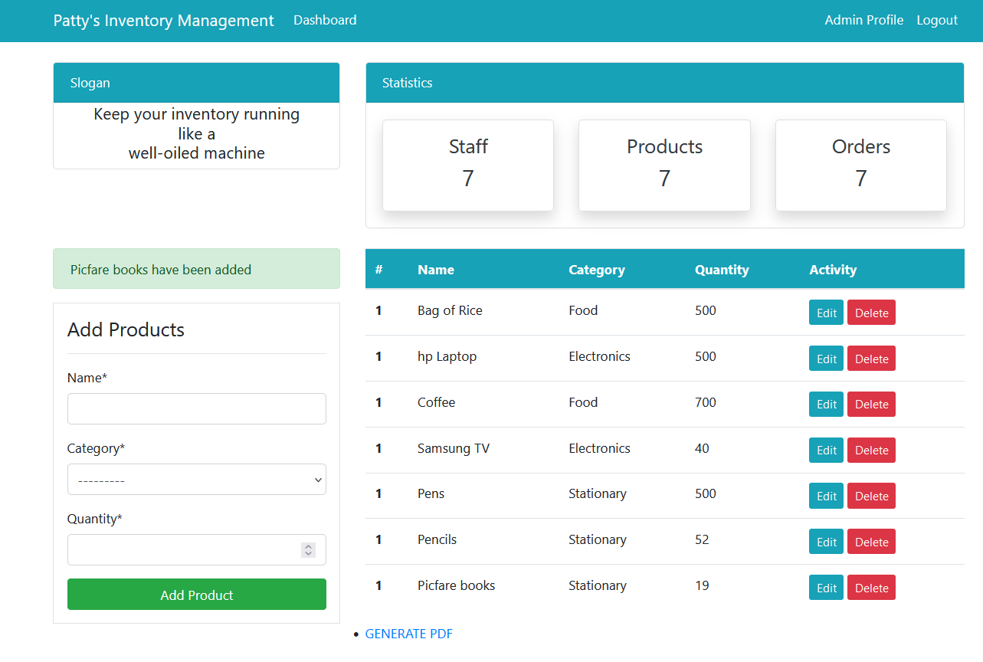Figure 12.Product Page

## **Challenges faced during development**

Risk management.

Evolving Requirements.

Managing project timelines.

Poor Communication.

## **Future Improvements**

Use of Barcode as well as bar code reader.

Online Payment

Feedback from customers

Refine the animations and enhance the search functionality to provide more intuitive results.

## **Conclusion**

Working on the Inventory Management system website with Django has enriched my web development skills, deepening my understanding of HTML, CSS, JavaScript, and Django. This project shown the value of attention to detail and responsive design in building user-friendly websites.

## **References**

Jayanth, S., Poorvi, M.B. and Sunil, M.P., 2017. Inventory management system using IOT. In *Proceedings of the First International Conference on Computational Intelligence and Informatics: ICCII 2016* (pp. 201-210). Springer Singapore.

Madamidola, O.A., Daramola, O.A. and Akintola, K.G., 2017. Web-based intelligent inventory management system. *International Journal of Trend in Scientific Research and Development*, *1*(4), pp.164-73.

<https://docs.djangoproject.com/>

<https://www.w3schools.com/django/>

Complete project available on

https://github.com/adrikopatty/inventoryproject.git